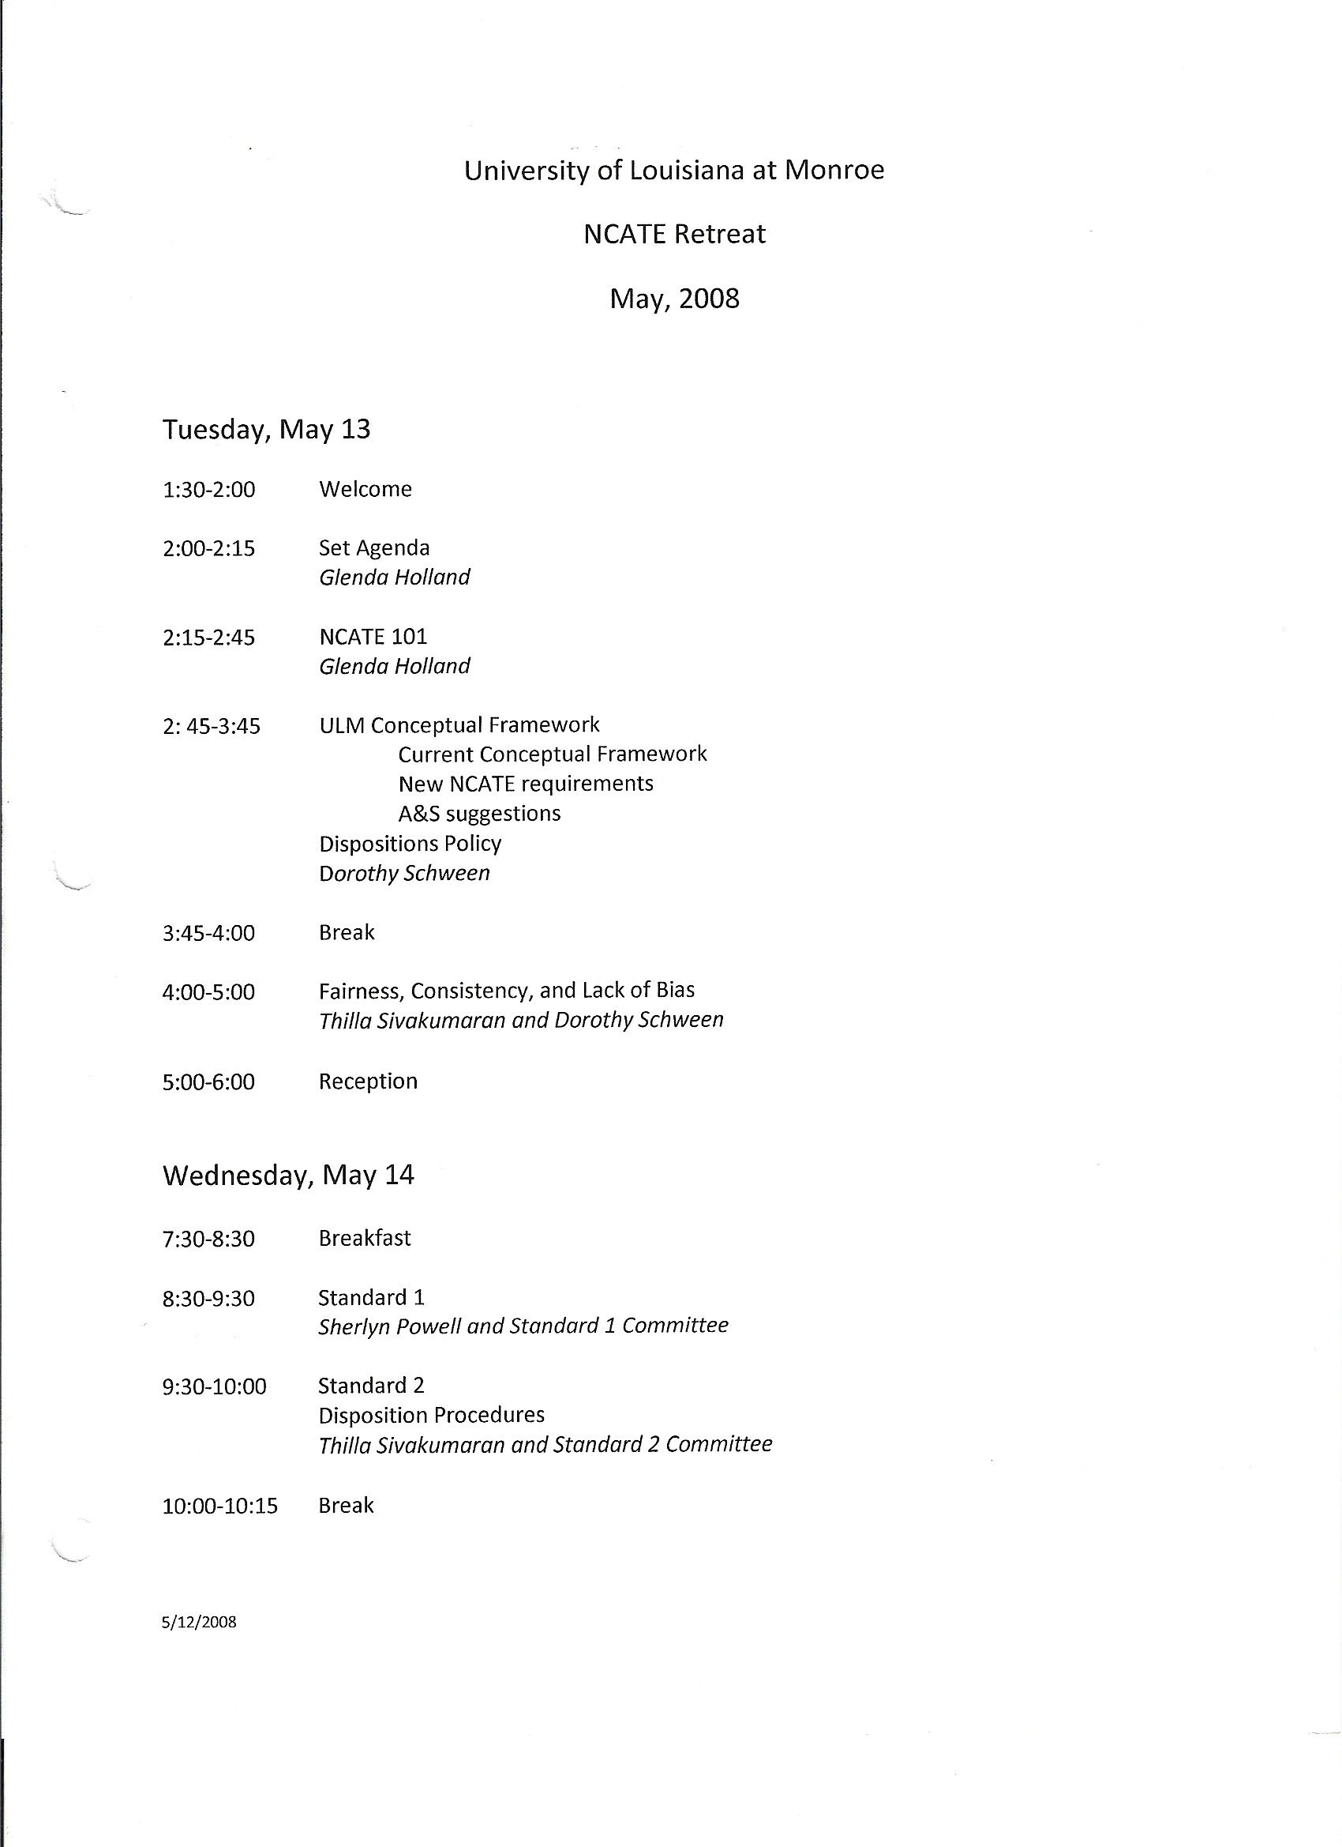
University of Louisiana at Monroe
NCATE Retreat, Shreveport, Louisiana
May 13 - 15, 2008

Tuesday, May 13
- ULM Conceptual Framework
Current Conceptual Framework
New NCATE requirements
A&S suggestions
Dispositions Policy
Dorothy Schween
Discussion
- Conceptual Framework
- Change “General Studies” to “Core Studies”?
- Should Technology and Diversity be added?
- Add “Serving a Global World”?
- Add “fairness and equity” to the narrative?
- Reduce the verbiage
- Have only one assess/instruct cycle

